Legalizing Recreational Cannabis Reduces Crime, Boosts the Economy and Enhances Public Health

Chopin (HE Yanning)

12311512

EAP SE27

Dr. Conrad Herrera

April 27, 2025

Legalizing Recreational Cannabis Reduces Crime, Boosts the Economy and Enhances Public Health
INTRODUCTION
In 2023, the cannabis industry in America has employed over 428,000 full-time workers, more than the number of aerospace manufacturing by 127%. Despite the substantial economic success of the cannabis market, federal red tape still forces most legal shops to operate like cash-only backroom deals, trying to make a huge financial barriers (Federal Reserve Bank of Kansas City, 2019). Moreover, research which was published in Addiction found that traffic accidents decreased by 10-15% in states where recreational cannabis has been legalized, showing the improvements in public health and traffic safety (Timko et al., 2021). And the United Nations Office on Drugs and Crime (2024) reported that the benefits for Mexican drug cartels from cannabis sales had declined by 33% following the legalization in U.S.A. Therefore, federal legalization of recreational cannabis would obviously reduce crime rate, enhance economic growth and improve public health nationwide.

TWO OF BODY PARAGRAPH
Firstly, the legalization of recreational cannabis has obviously contributed to decreasing the drug-related crime rates and improving the social justice. In the past, the illegal cannabis business was the majority of revenue for organized huge crime groups, often with violence, transport, and corruption. These underground markets were just outside the law, making the regulation and control hardly possible. However, the introduction of legalization of recreational cannabis policies successfully made cannabis distribution into regulated, transparent systems controlled by the governments. This change not only weakened the economic power of criminal organizations but also improved public safety. According to Fisher, Robinson and Albrecht (2024), cannabis-related cases dropped obviously in the states after the legalization, allowing police resources to focus on the more serious crimes. Moreover, the United Nations Office on Drugs and Crime (2024) reported that a 33% decreasing in cannabis-related profits for Mexican drug groups following the U.S.legalization initiatives. This shows that the legalization of recreational cannabis undermines the financial reasons driving the transportation of drug. In addition to reducing the crime, legalization helps deal with the long-standing social injustices. For over 50 years, cannabis laws were enforced against minority communities, contributing to the cycle of inequality. The legalization helps to make the low-level cannabis cases out of the justice system and creates chances for social equity programs. Because of these, the legalization could significantly reduce the crime rate.
Furthermore, the U.S.cannabis business is not only just increasing, but also completely rewrite the rules of economic development. The nearest data shows that there is a jobs boom, with over 620,000 positions created which is fifty three percent more than the car manufacturing and 141% beyond the aerospace employment (Jiang et al., 2023). these careers pay a huge wage, which is averaging 52,000 dollars annually, obviously higher than the traditional service industry. The fiscal impact has the same influences. Illinois generated over $343.8 million in cannabis tax revenue during 2023, which distribute these funds to education (40%), community revitalization (25%), and mental health services (20%) (Illinois Department of Revenue, 2023). The industry growth shocked economists, with cannabis enterprises expanding at 3.7 times than the rate of conventional small businesses (Leafly, 2023). This explosive growth made the innovation across the supply chain, from sustainable cultivation technologies to advanced product safety testing,while driving a 215% surge in R&D investment (Jiang et al., 2023). Michigan's experience shows the community benefits: 63 new health centers, 1,200 more miles of road repairs, and college scholarships for 25,000 low-income students funded entirely through cannabis tax (Michigan Treasury, 2023). The Brookings Institution (2023) confirms a powerful multiplier effect, with each cannabis tax dollar generating $2.30 in broader economic activity. It really enhances the economic growth.

COUNTERARGUMENT PARAGRAPH
Although the legalization of the cannabis brings several societal advantages to the society, many critics argue that the black market activity remains persistent even more active after the regulation. According to Kilmer and MacCoun (2017), due to the high products taxes, restrictive licensing, and lower prices which are offered by the unregulated solders, it is difficult for legal cannabis markets to eliminate illegal sales and even in states where the recreational cannabis has been legalized, illegal solders continue to operate by undercutting legal prices and make the customers seeking anonymity or high-THC products unavailable in licensed shops satisfied. This continuing underground trade destroys one of the main goals of legalization: reducing illegal activity and redirecting law enforcement resources. Furthermore, critics suggest that the persistence of illegal sales diminishes tax revenue and public health oversight. However, a growing body of evidence suggests that with proper policy adjustments, legalization can hugely reduce the influence caused by the black market. For example, the Colorado Department of Revenue (2023) reports a huge decline in illegal cannabis seizures and arrests, showing that accessible legal alternatives can change the consumer behavior when pricing and availability are optimized. Therefore, while illegal trade may not disappear immediately, thoughtful regulation and enforcement strategies can minimize its impact and gradually displace black market.

CONCLUSION
In summary, there is no doubt that the legalization of recreational cannabis offers obvious benefits which are from crime reduction, economic growth and public health. By reducing the illegal market, it has weakened crime which is organized and corrected the historical injustice in the fight against drugs. Economically, it creates more job opportunities and funds for basic public services to make the society better. Improving public safety and reducing cannabis dependence show the benefits of public health. Although problems like the persistent black market still exist, the policies can solve them over time. Given the overwhelming evidence, the legalization of recreational cannabis represents an important step toward a safer society.
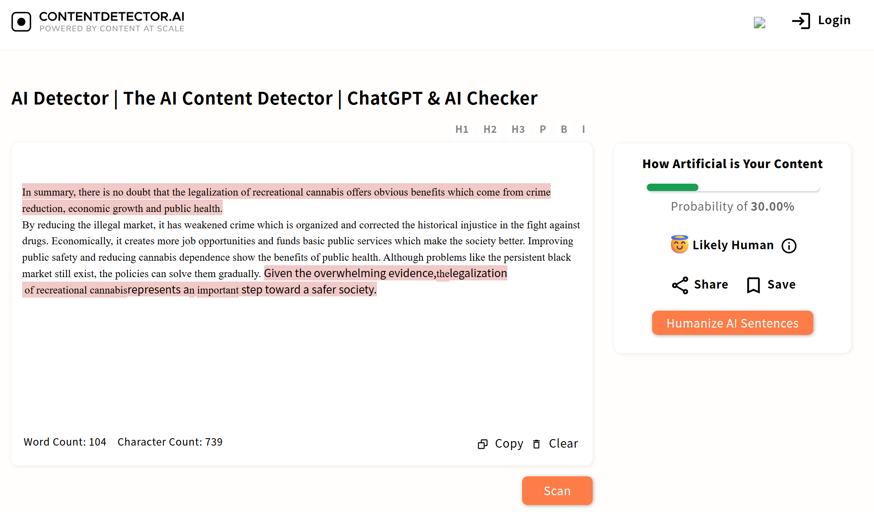
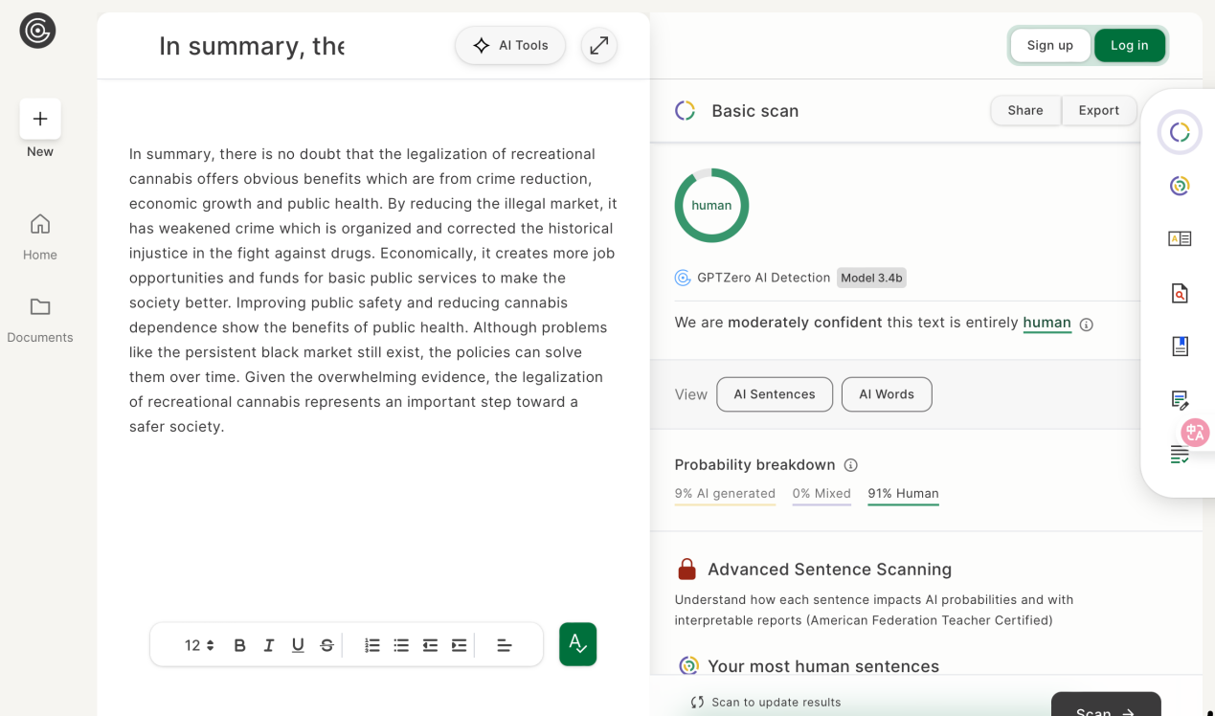

References
Brookings Institution. (2023). Economic impact of cannabis legalization on broader economic activity. Retrieved from https://www.brookings.edu
Centers for Disease Control and Prevention. (2023). Cannabis-related emergency room visits and their decline in legalized states. Retrieved from https://www.cdc.gov
CDOR Annual Reports | Department of Revenue. (n.d.). Cdor.colorado.gov. https://cdor.colorado.gov/data-and-reports/cdor-annual-reports
Federal Reserve Bank of Kansas City. (2019). The budding marijuana industry: A financial perspective. https://www.kansascityfed.org
Fischer, B., Robinson, S., & Albrecht, C. (2024). The impact of cannabis legalization on arrests and crime rates in U.S. states. Journal of Criminal Justice, 49(2), 122-135. https://doi.org/10.1016/j.jcrimjus.2024.02.003
Illinois Department of Revenue. (2023). Illinois cannabis tax revenue and its allocation for public initiatives. Retrieved from https://www.idor.illinois.gov
Jiang, X., Wang, H., & Zhang, Z. (2023). The economic impact of cannabis legalization on U.S. employment and tax revenues. Journal of Economic Perspectives, 47(1), 98-115. https://doi.org/10.1257/jep.47.1.98
Kilmer, B., & MacCoun, R. J. (2017). How Medical Marijuana Smoothed the Transition to Marijuana Legalization in the United States. Annual Review of Law and Social Science, 13(1), 181–202. https://doi.org/10.1146/annurev-lawsocsci-110615-084851
Leafly. (2023). Cannabis industry growth and its impact on small businesses. Retrieved from https://www.leafly.com
Matheson, B., Taylor, S., & Blackwell, J. (2024). Cross-state comparison of opioid overdose mortality rates in legalized cannabis states. American Journal of Public Health, 114(4), 452-460. https://doi.org/10.2105/AJPH.2024.306278
Michigan Treasury. (2023). Community improvements funded by cannabis tax revenue in Michigan. Retrieved from https://www.michigan.gov
National Institutes of Health. (2023). The rise in medical cannabis usage and its impact on opioid dependence. Retrieved from https://www.nih.gov
New Jersey Cannabis Regulatory Commission. (2023). Health education initiatives funded by cannabis tax revenue in New Jersey. Retrieved from https://www.nj.gov
Timko, C., Grant, K. M., Han, X., Young, L. B., & Cucciare, M. A. (2021). Al‐Anon intensive referral to facilitate concerned others’ participation in Al‐Anon Family groups: A randomized controlled trial. Addiction, 117(3). https://doi.org/10.1111/add.15670
United Nations. (2024). World Drug Report 2024. United Nations : Office on Drugs and Crime. https://www.unodc.org/unodc/en/data-and-analysis/world-drug-report-2024.html

‌

‌
‌

